The JAD Interview

*The interview is the primary technique for information gathering during the systems analysis phases of a development project. It is a skill which must be mastered by every analyst. The interviewing skills of the analyst determine what information is gathered, and the quality and depth of that information. Interviewing, observation, and research are the primary tools of the analyst.*

**What Is an Interview?**

**A definition**

An *interview* is "a formal face-to-face meeting, especially, one arranged for the assessment of the qualifications of an applicant, as for employment or admission.... A conversation, as one conducted by a reporter, in which facts, or statements are elicited from another." (*The American Heritage Dictionary*, Second College Edition)

The interview is the primary technique for information gathering during the systems analysis phases of a development project. It is a skill which must be mastered by every analyst. The interviewing skills of the analyst determine what information is gathered, and the quality and depth of that information. Interviewing, observation, and research are the primary tools of the analyst.

The interview is a specific form of meeting or conference, and is usually limited to two persons, the interviewer and the interviewee. In special circumstances there may be more than one interviewer or more than one interviewee in attendance. In these cases there should still be one primary interviewer and one primary interviewee.

**Types of Interviews**

During the analysis process, interviews are conducted for a variety of purposes and with a variety of goals in mind. An interview can be conducted at various times within the process for

1. Initial introduction
2. Familiarization or background
3. Fact gathering
4. Verification of information gathered elsewhere
5. Confirmation of information gathered from the interviewee
6. Follow-up, amplification, and clarification

**Interviewing Components**

The interview process itself consists of a number of parts.

1. Selection of the interviewee and scheduling time for the interview
2. Preparation of interview questions, or script
3. The interview itself
4. Documentation of the facts and information gathered during the interview
5. Review of the interview write up with the interviewee
6. Correction of the write up, sign-off, and filing

**What Are the Goals of the Interview?**

At each level, each phase, and with each interviewee, an interview may be conducted to:

1. Gather information on the company
2. Gather information on the function
3. Gather information on processes or activities
4. Uncover problems
5. Conduct a needs determination
6. Verification of previously gathered facts
7. Gather opinions or viewpoints
8. Provide information
9. Obtain leads for further interviews

**Interviewing Guidelines**

Given these various phases and the variety of goals of an interview, the importance of a properly conducted interview should be self-evident. Since each interview is in fact a personal exchange of information between two personalities, a set of guidelines for the interviewer should be established to ensure that nothing interferes with the stated goal, i.e., gathering complete, accurate information. The interview is not an adversary relationship; instead it should be a conversation. Above all it is a process, and like most processes it has certain rules and guidelines which should be followed.

1. First and foremost, establish the tone of the interview.
2. Let the interviewee know the reason for the interview and why he or she was selected to be interviewed.
3. Stress that the interviewee's knowledge and opinions are important, and will aid in the analysis process.
4. Gain the interviewee's trust and cooperation early on, and maintain it throughout.
5. Establish what will happen to the information gathered.
6. Determine any areas of confidentiality or restricted information.
7. Let the interviewee know that candor and honesty will be valued and that nothing will be published or passed on until it has been reviewed and verified by the interviewee.
8. Firmly establish that there are no negative consequences to being interviewed.

**Dos and Don'ts of Interviewing**

The rules of interviewing are similar to the rules which govern most human interactions and to the rules which govern most investigative and problem-solving processes. In effect they can be called the rules of the game.

1. Do *not* assume anything.
2. Do *not* form pre-judgments.
3. Do ask questions which start with who, what, where, when, why, and how, where possible.
4. Do ask both open and closed questions.
5. Do verify understanding through probing and confirming questions.
6. Do avoid confrontation.
7. Do act in a friendly but professional manner.
8. Do *not* interrupt.
9. Do listen actively.
10. Do take notes, but do *not* be obtrusive about it.
11. Do let the interviewee do most of the talking
12. Do establish rapport early and maintain it.
13. Do maintain control over the subject matter.
14. Do *not* go off on tangents.
15. Do establish a time frame for the interview and stick to it.
16. Do conclude positively.
17. Do allow for follow-up or clarification interviews later on.
18. Do be polite and courteous.

**Who to Interview**

One of the analyst's first and most important tasks during the data gathering phase of the analysis process, is to determine who has to be interviewed. This includes selecting the interviewees, understanding what can be expected from an interview of a person at a specific level, how to verify the information received from an interview, and, most important, understanding the perspective of the person being interviewed.

Most analysis projects have a user liaison assigned to the analysis team. It is this person's function to introduce the analyst to those being interviewed, to provide background information, and to interpret (or translate) the information which is obtained from the interviews. This person usually has the additional role of assisting the analyst in choosing those to be interviewed, scheduling the interviews themselves, and in some cases attending the interviews.

Under normal conditions, the analyst will have access to all people in the user area, although normally there is no need to interview them all. This is especially true if the user area is very large.

Generally speaking, the list of those to be interviewed can be divided into three sections:

1. the most senior manager,
2. his or her subordinates and junior managers, and
3. line workers, clerks, production people, sales staff, etc. See Figure 7.1 for interviewing and verification sequences.

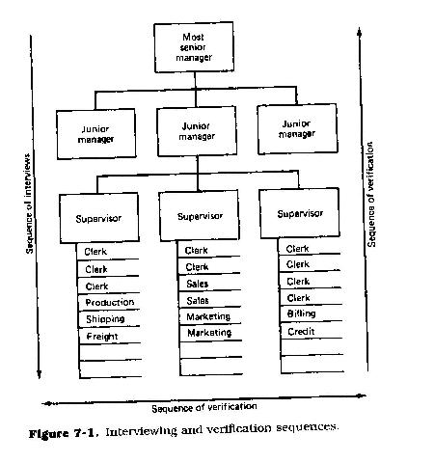

**The Need for Documentation**

Everyone talks about the weather but no one can do anything about it. In the case of documentation, everyone talks about it but few do it; however, unlike the weather, most people can document, and document effectively.

Documentation, however painful and tedious it may seem, is one of the most critical tasks of analysis. The documentation produced as a result of the analytical interviews, the analyst's observations and research, and ultimately, the total analysis phase of the project serves a number of purposes.

**Permanence.** The need for documentation is rooted in semantics and human memory. Verbal communications are both transitory and subject to interpretation. The average person has a language working set of about 500 to 1000 words. The written working set, by contrast, is much larger, perhaps by as much as an order of magnitude. Verbal communication is augmented by inflection, body language, and by a process of feedback and interaction, all of which serve to clarify the ambiguous, the ill-defined, and ill-understood. Human memory is imperfect. Words communicated verbally can only be recalled and examined with difficulty, if at all.

**Precision and recall.** A written document is more precise and may be reviewed repeatedly until understanding is achieved. It has the added advantage that small changes can be made to it without having to restate the entire premise or thought. Additionally, once an idea is written down, it may be recalled at will exactly as first presented and may be completed by someone other than the original author, or authors. Because there is little feedback from the written word, one can only take issue with misstatements of fact or with ambiguous wording. If it isn't written down, it isn't there.

**Graphics.** Documentation usually includes both a narrative portion and an illustration portion. These illustrations serve to amplify and enhance the narrative. One picture can be worth many thousands of words, if properly drawn. The graphics of the analytical documentation, whether it employs simple flowcharts, HIPO diagrams, data flow diagrams, or powerful modeling techniques such as those based upon the entity-relationship-attribute approach, presents the user and the analyst with a way to walk through the picture developed from the analysis, and ultimately walk through the design developed from the analysis. These walk-through sessions enable both to understand the environment and to detect any ambiguities and anomalies. Illustrations have the added advantage that they can be viewed in their entirety, whereas narrative may only be viewed in fragments.

**Functions of Documentation**

Documentation serves to clarify understanding, and perhaps most important, it provides the audit trail of the analyst. That is, it creates the records which can be referred to at some later date and which serve as the basis for future work and decisions.

Good documentation precludes the need to return to the interviewee for a repetition of ground previously covered. Good documentation can be reviewed over and over until adequate understanding is achieved.

Documentation is tedious and sometimes boring. But it is also vital. Good documentation allows other analysts and the analyst's successors to pick up where the first left off, should he or she be reassigned. Documentation is necessary if the next project phases are to be successful, since they are predicated on the results of the analysis. To a very real extent, analytical documentation provides the road maps for the remainder of the project. If the maps are faulty, or incomplete, the succeeding teams may wind up in a swamp, or worse, in quicksand.

Most important, the finalized documentation serves as a contract between the user and the data processing developer. In it the analyst has described the user's environment, the analyst's understanding of the user's needs and requirements, and with the proposal for a future environment, the analyst's description of the system to be designed and built by the developers. With the user's sign-off, or approval of these documents, a contract is created between the two. Barring unforeseen changes in the business environment, the problems described in the documentation will be rectified and the environment proposed will be the one built and installed for the user.

The document becomes, in effect, a statement of the work to be performed. The time to modify and change it is before the work begins; afterward it may be too late. From the developer's perspective, any post sign-off changes may require a re-negotiation of either time frames, costs, or resources. From the user's perspective, the design is what is contracted for and what he or she is paying for. If the final product does not conform to the proposal, then it is up to the developer to rework the product until the user is satisfied.

**Documenting the Interview**

The interview is not complete until it has been documented. See Figure 7.2 for a header form for sample interview notes. The documentation of the interview need not be a verbatim transcript of what was said but should cover the following items.

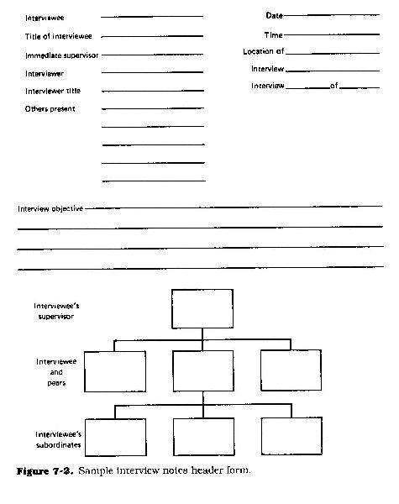

1. Who was interviewed and who did the interviewing, including the title of the interviewee, the interviewee's function and immediate superior, and interviewer name and title
2. The date, time, and location where the interview took place
3. Names and titles of any other persons who were in attendance
4. The stated objective of the interview
5. The interviewee's job or functional description
6. The interviewee's organizational chart and organizational charter, if appropriate. A complete description of any facts which were obtained during the interview
7. A complete description of any opinions stated by those interviewed
8. Any conclusions drawn from the facts or opinions as presented
9. Any business problems uncovered during the interview
10. Samples of any forms, reports, charts, graphs, documents, manuals, policies, standards, or procedures referred to or discussed during the interview
11. Any charts or diagrams drawn as a result of the information gathered during the interview
12. Any relevant comments made by the interviewee
13. Any numbers, transaction or document volume information, task timing information, capacity information, quality information, etc., gathered during the interview

*From: A Professional's Guide to Systems Analysis, Second Edition*  
Written by Martin E. Modell  
*Copyright © 2007 Martin E. Modell*